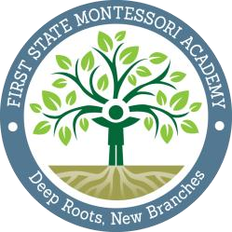
First State Montessori Academy
D e e p R o o t s, N e w B r a n c h e s
1000 N. French Street, Wilmington, DE 19801
www.firststatemontessori.org | 302-576-1500

Certification of Intent to Enroll for the 2022-2023 School Year

Signing this document ensures that you, the student’s parent or guardian, intend to enroll your child into First State Montessori Academy for the 2022-2023 school year. We are excited to have you!

I, __________________________________________________, the parent/guardian of
(parent/guardian name)

_____________________________________, confirm my decision to enroll my child at
(student name)
First State Montessori Academy (FSMA) for the 2022-2023 school year.

I understand that the State requires my child to remain in this charter school for at least one year, unless good-cause conditions constitute otherwise. Additionally, I understand that if I choose to remove my child from First State Montessori Academy in the 2022-2023 school year and attempt to enroll my child in another Delaware public school, the new school is not required by law to accept my application.

________________________________________________
Signature of Parent/Guardian

________________________________________________
Print Name of Parent/Guardian

____________________
Date

Please return this signed document to FSMA by March 18th, 2022
email to sherry.digiovanni@fsma.k12.de.us or fax to 302-576-1500

