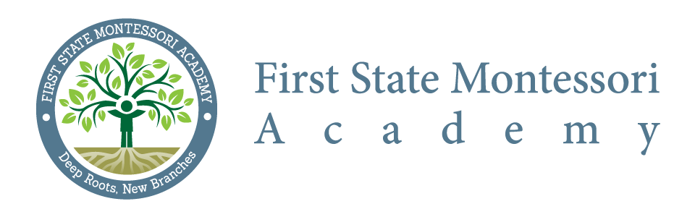

Citizen Budget Oversight Committee
Meeting Minutes

Meeting Date: January 16, 2020
Commencement: 6:40 PM
Adjournment: 7:18 PM
Location: First State Montessori Academy

In attendance: Courtney Fox, Liz Madden, Jill Pyle, Robbie Smith, Dick Riggs, Rob Tice, Matt Petrin and Karen Thorpe (via phone)

Regrets: Mary Falkenburg, Zeke Allinson

Minutes:
- Reviewed Monthly Budget Report – Presented by Karen Thorpe
  - No objections or concerns noted
  - Revenues and expenditures are trending as expected
  - Capital budget includes upgrades to the playground, a new roof and hallway floors

- New business
  - Courtney noted that the new HVAC system was in the last stages of install

- Next meeting was scheduled for Thursday, 03/19/2020 at 6:30 PM

- There being no further business, meeting adjourned at 7:18 PM

