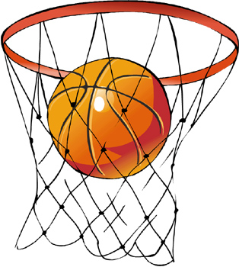
Join FSMA’s Basketball Team!
FSMA is partnering with the YMCA of Delaware
and having FSMA teams for the Winter Season!

Who is eligible? 7 – 10 year old boys and girls (teams will be created based on age – 8U and 10U) (Students must be in 2nd grade or above to participate)
Who will coach? Elementary basketball teams are typically coached by parent volunteers. If you are interested in coaching or helping to coach, please check that box below. Our program can only run if we have enough coaches.

Who will we play? FSMA will play other teams that are part of the YMCA Basketball League.

Dates and Times: Games are on Saturdays at Wilmington Friends School. Coaches will schedule practices outside of the games - it will be dependent upon your coach’s schedule and availability. Practices will be held at FSMA afterschool or in the evening once a week.

Cost – There is a $100 fee to join the team. This will cover all costs (team registration and team shirt).

To sign up, please fill in the attached sheet and return it to FSMA by 11/8 with $100 fee (checks made out to FSMA or cash).

Please note that FSMA is facilitating the creation of the teams but all oversight will be done by parent volunteers and the YMCA of Delaware.

You will be contacted in late November with your team assignment. Practices will start in December with games starting in January.

FSMA
Basketball Team

Student Name: ________________________________________

Grade: ____ Current Age: ______ Date of Birth: _________________________

Parent Signature: _____________________________________ Date: _________

Child’s Shirt Size: Youth S Youth M Youth L Youth XL Adult S Adult M

Parent/Contact information:

Name: ________________________________________
Email Address: ____________________________________________
Phone Number: _____________________________

Age Level:

____ 8 and Under Co-Ed (My child will be 7 or 8 during the entire season through March 1)

____ 10 and Under Co-Ed (My child will be 9 or 10 during the entire season through March 1)

Parent Involvement:

____ I have coached before and am interested in coaching my child’s team.

____ I have not formally coached before but am interested in coaching my child’s team.

____ I would be interested in co-coaching my child’s team

FSMA Parent Contract – Basketball

In recognition of my child being accepted to participate with a FSMA sports team, I (we) agree to read and follow the standards listed below. Please initial each:
____ I will remain in the spectator area during competitions, which is on the opposite side of the field from the team benches, or in designated areas as stated by those in charge of events.
____ I will show respect for all involved with the game including coaches, players, opponents, opposing fans, table crew, and officials.
____ I will support coaches and officials working with my child in order to encourage a positive and enjoyable experience.
____ I understand that games can be exciting for my child as he/she deals with the fast-paced action of the game or competition, responds to opponents, referees, teammates, and listens to coaches. I will not yell out instructions. During the game I will make only sportsmanlike comments that encourage my child and other players on both teams.
____ I understand and accept the importance of practice and game attendance and will make every reasonable effort to attend all scheduled practices and games and to notify my coach in advance if I cannot attend a practice or game.

Player Name: _____________________________________________________
Parent Signature: __________________________________________________

Please remember that FSMA is rooted in Montessori principles. All activities, and in this case sports, will be guided by the core values of the school and support each child in his/her positive growth as an athlete.

