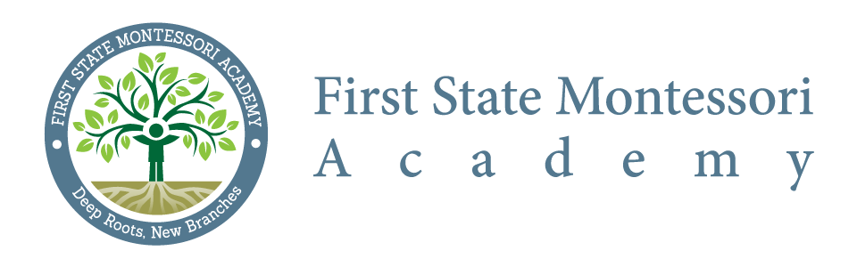
Citizen Budget Oversight Committee – Meeting Minutes
Meeting Date: April 16, 2015 @ 6:30 p.m.
Commencement: 6:35 PM
Adjournment: 7:20 PM
Location: First State Montessori Academy

In attendance: Courtney Fox, Liz Madden, Jodi O’Ferrall, John Carwell (DOE), Karen Thorpe (Innovative Schools)
Regrets: Jill Pyle, DaWayne Simms, Kelly Veacock, Zeke Alinson
Meeting Minutes:
- Review / Approval of Minutes from CBOC meeting held on March 19, 2015
  - Reviewed CBOC by-laws to confirm protocol for actions when there is no quorum – bylaws do not require quorum, nor does state regulation (per Karen Thorpe)
  - Motion made by Liz Madden to accept minutes and second by Jodi O’Ferrall – so moved

- Monthly Budget Report review (Mar 31 – FY 15) to be presented by Innovative Schools
  - General inquiries only; no significant concerns with the report as presented
  - Approved report for presentation to the FSMA Board at their next scheduled meeting

- New business points (if applicable)
  - Sean Boyd (treasurer) has resigned from the FSMA Board as it begins transition from founding board to ongoing board. A new treasurer will be named at next board meeting.
  - Next meeting will include an update on 2015/2016 budget process
  - Request to review payee report from state system at May meeting – Courtney or Karen will provide
  - Will also review feedback on fixed income policy and procedures draft as distributed at March meeting
Next Meeting: Thursday, May 21, 2015

