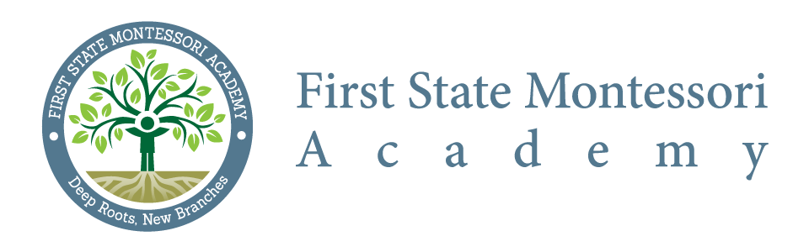
Citizen Budget Oversight Committee – Meeting Minutes
Meeting Date: May 19, 2016 @ 6:30 p.m.
Commencement: 6:40 pm
Adjournment: 7:42 pm
Location: First State Montessori Academy

In attendance: DaWayne Sims, Courtney Fox, Liz Madden, Jodi O’ Ferrell, Karen Thorpe (Innovative Schools), Richard Riggs, Will Chastain
Regrets: Robbie Smith, Jill Pyle, Zeke Allinson
Meeting Minutes:
- FSMA Audit Plan (June 30, 2016) Overview – presented by Barbacane, Thornton & Company LLP

- Review / Approval of Minutes from CBOC meeting held on March 17, 2016
  - Minor adjustment noted regarding meeting attendees
  - Minutes approved with noted corrections to attendance

- Review / Approval of monthly Budget/Web Report (Apr 30 – FY 16) prepared by ISD
  - General inquiries only; no significant concerns noted with the report as presented

- New business points
  - Next CBOC meeting scheduled for July 21, 2016
  - Request made to include review of Vendor Cross-Tab report at next CBOC meeting

