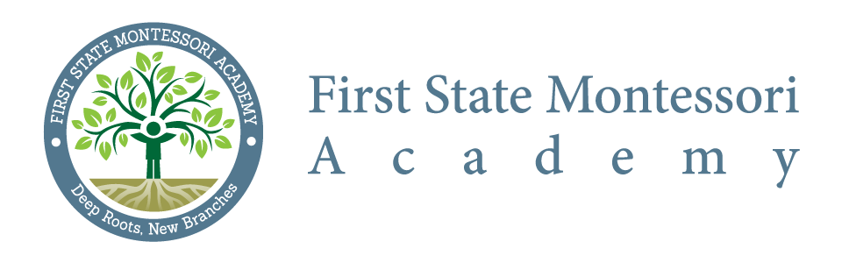
Citizen Budget Oversight Committee
Meeting Minutes
Meeting Date: August 14, 2014
Commencement: 6:00 p.m.
Adjournment: 7:45 p.m.
Location: First State Montessori Academy
In Attendance: Courtney Fox, Liz Madden, Jodi O’Ferrall, Kelly Veacock, DaWayne Sims, Jill Pyle, Innovative Schools (Eliseo Sierra)
Absent: Zeke Allinson

- Reviewed current FSMA Budget Report - (presented by Eliseo Sierra of Innovative Schools)

- Performed extensive review of Receipts and Expenditures Coding (Salaries/Grants/Entitlements/etc)
- Reviewed Chart of Accounts details and requested full overview in preparation for September meeting (expedited review to be performed by Innovative Schools with Courtney Fox and Liz Madden)
- CBOC postponed adoption of FY’15 – as of July, 31 2014 - budget until additional reviews are completed

- Reviewed and adopted CBOC meeting minutes from July 17, 2014

- Adopted FSMA – CBOC Bylaws at 7:35 pm

