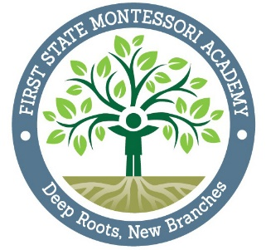
First State Montessori Academy, Inc
1000 N. French Street
Wilmington, DE 19801

Public Board Meeting Agenda
Thursday, August 27. 2015
6:30 PM

- Call to order

- Introduction of Board Members

- Approval of 7-23-15 Minutes

- Committee Reports/Recommendations

- Finance
- Development
- Academic Excellence
- Governance
- Head of School

- Unfinished Business
  - DANA Evaluation
  - Student Retention

- New Business

